# 

FY BTech SEM I 2021-22

Engineering Physics Lab Course

# Experiment No: 8

**Title: Numerical Aperture of Optical Fibre**

**Name : Eshan Kalp Trivedi**

**Roll No:** 16010221038

**Branch:** ETRX

**Batch :**  D2

**Aim:**

To find the numerical aperture of a given optic fibre and hence to find its acceptance angle.

**Setup Diagram:**

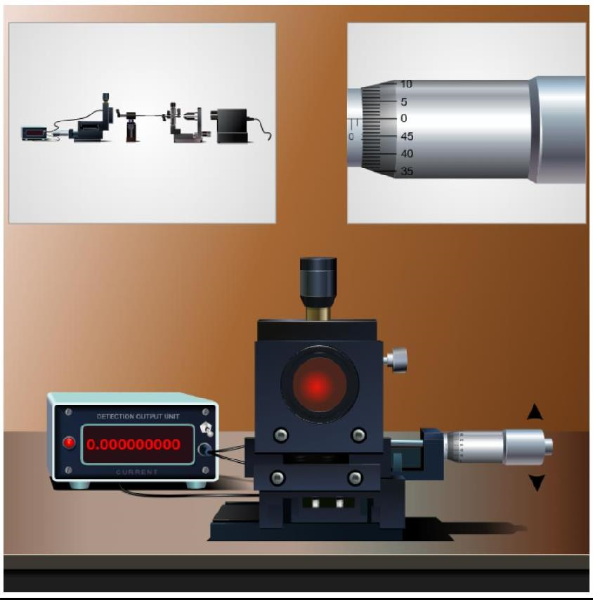

**Screenshot of Experimental setup:**

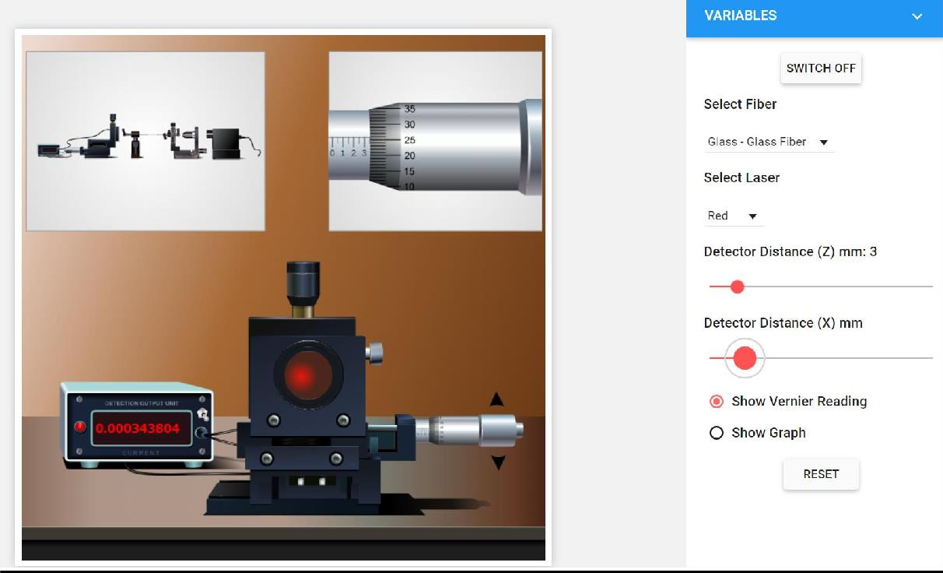

**Procedure:**

**Preliminary Adjustment**

* Drag and drop each apparatus in to the optical table.
* Then Click “Start” button.
* Switch On (now you can see a spot in the middle of the detector)
* After that select the Fibre and Laser for performing the experiment from the control options.

**To perform the experiment**

* Set the detector distance Z (say 4mm). We referred the distance as “d” in our calculation.
* Vary the detector distance X by an order of 0.5mm, using the screw gauge (use up and down arrow on the screw gauge to rotate it).
* Measure the detector reading from output unit and tabulate it.
* Plot the graph between X in x-axis and output reading in y-axis. See figure 5.
* Find the radius of the spot r, which is corresponding to Imax/2.71 (See the figure 5).

**Observation Table:**

**Detector Distance (Z) = 3mm**

**Fibre selected: Glass-Glass fibre**

**Laser Selected: Red**

**Least count = 0.01 mm**

|  |  |  |  |  |
| --- | --- | --- | --- | --- |
| **Sr. No.** | **Screw Gauge Reading** | | **Distance X (mm)** | **I µA** |
|  | **H.S.R.** | **P.S.R.** |
| **1.** | 2.5 | 0.01 x 44 | 2.94 | 0 |
| **2.** | 3 | 0.01 x 32 | 3.32 | 0.000000582 |
| **3.** | 3.5 | 0.01 x 24 | 3.74 | 0.000266343 |
| **4.** | 4 | 0.01 x 20 | 4.20 | 0.023089304 |
| **5.** | 4.5 | 0.01 x 11 | 4.65 | 0.183528565 |
| **6.** | 5 | 0.01 x 5 | 5.05 | 0.193142387 |
| **7.** | 5.5 | 0.01 x 47 | 5.97 | 0.027615739 |
| **8.** | 6 | 0.01 x 39 | 6.39 | 0.000564566 |
| **9.** | 6.5 | 0.01 x 33 | 6.83 | 0.000001171 |
| **10.** | 7 | 0.01 x 29 | 7.29 | 0 |

**Calculations:**

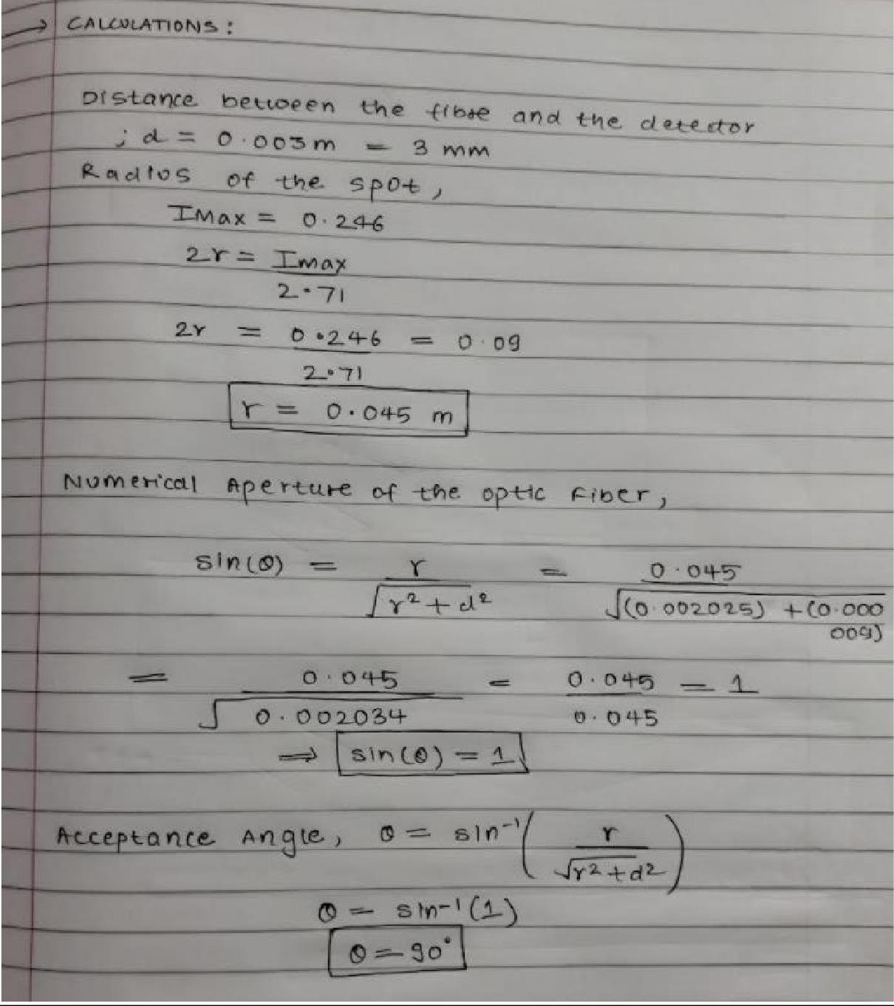

**Graph:**

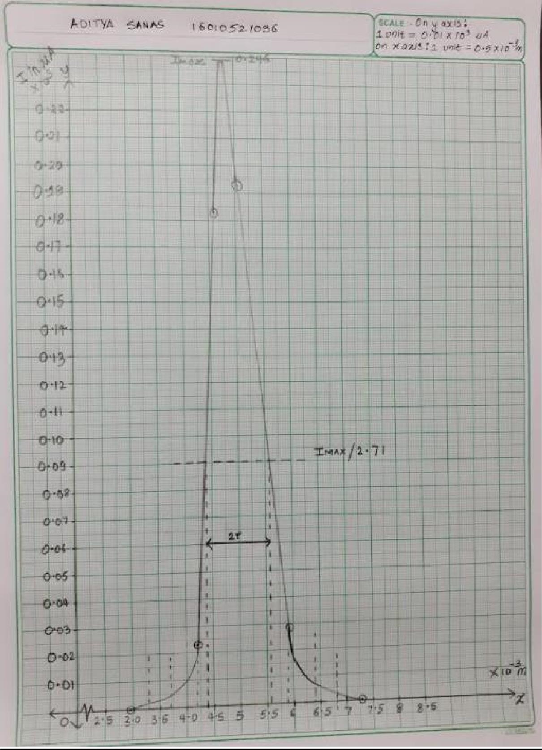

**Results:**

Radius of the Spot: 3mm = 0.003 m

Numerical aperture of the optic fibre is = **sin 90° = 1**

Angle of acceptance = **90°**

**Conclusion:**

Thus, we have successfully calculated the value of Numerical Aperture of the Optical Fibre.

**Sign of Faculty In-charge**

**Department of Mechanical Engineering**